Dev log for ToastDisc

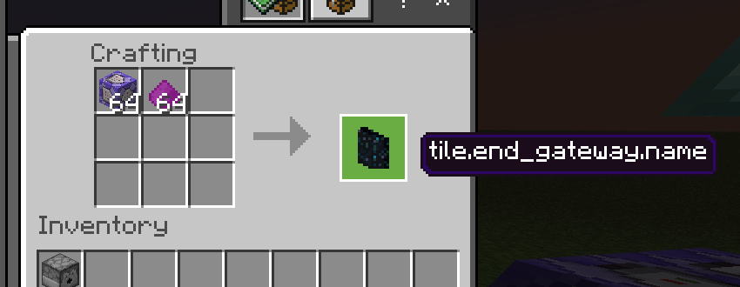

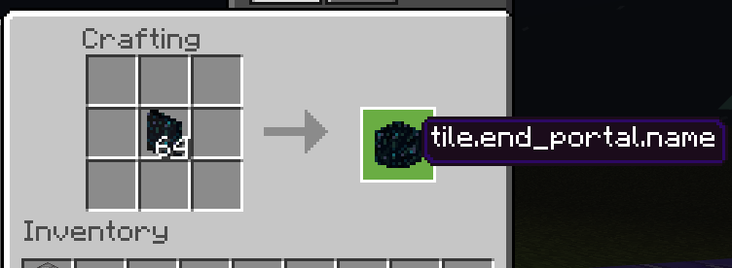

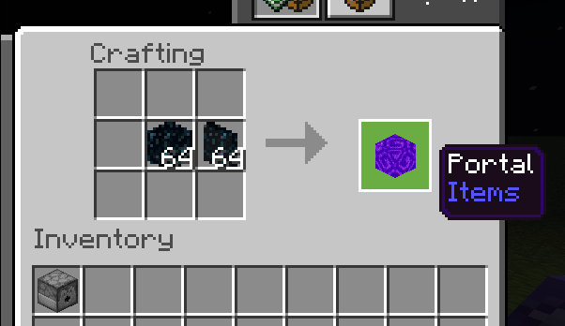





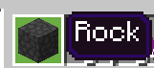

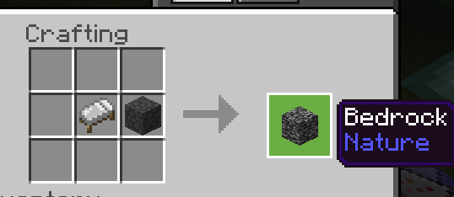

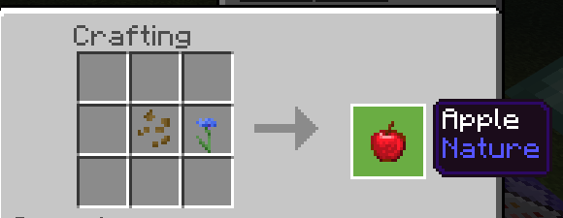

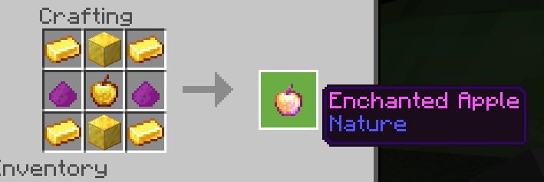

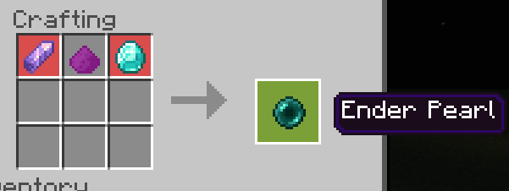

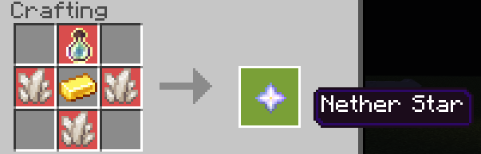

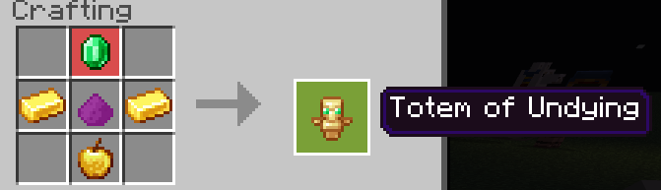

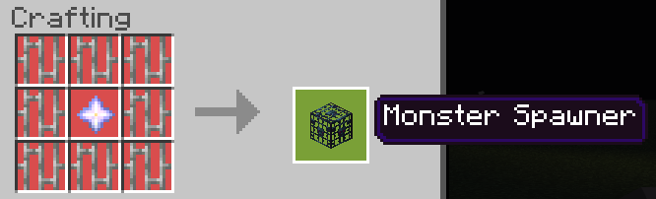

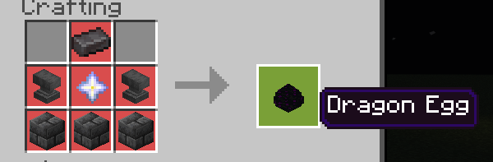

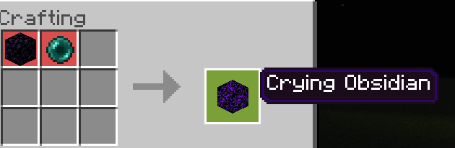

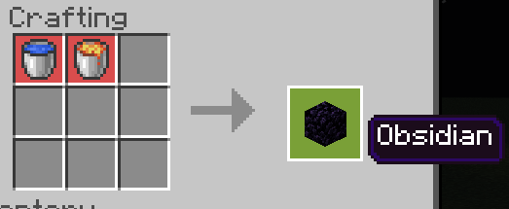

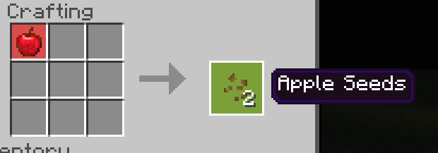

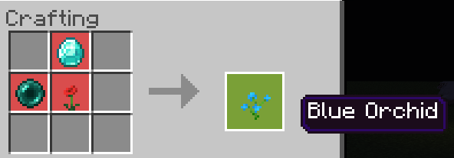



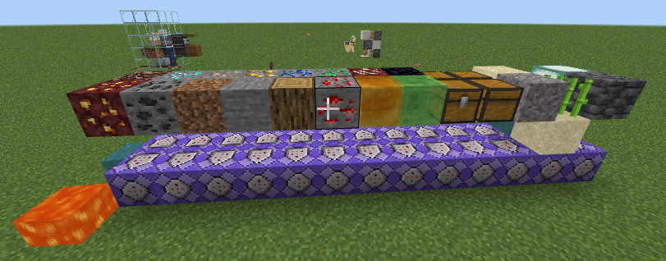

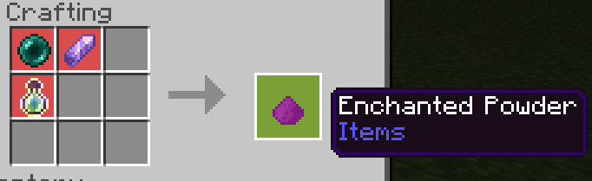

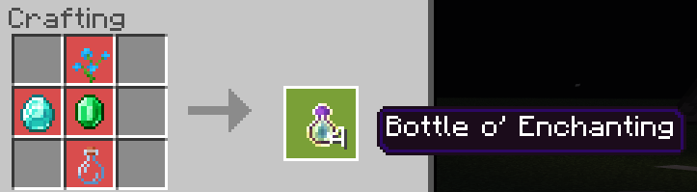



2147483647

I will be back tmmrow lol

[THE NEXT DAY....]

5/8/2022

i smell like chicken nuggettttttttttttttttttttssssssssssss

jk

also lol

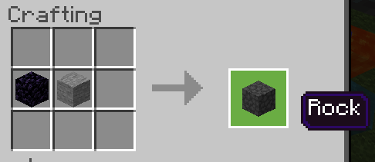

my world name is to long.

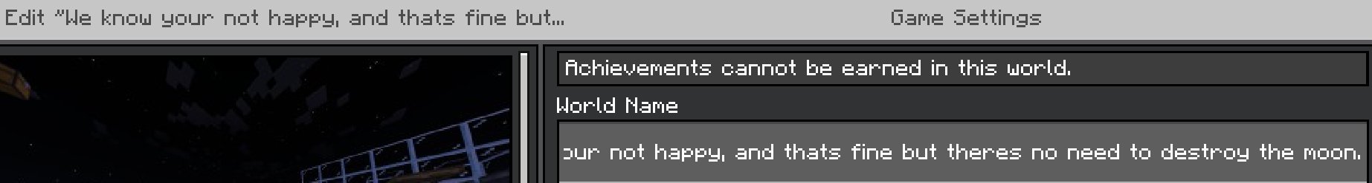

e

88(

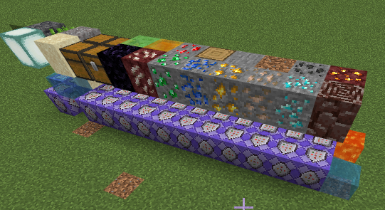

)88

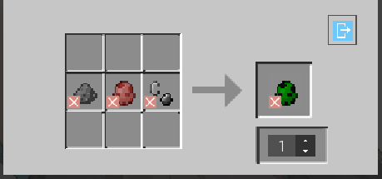

gunpowder, pig egg and flint and steel is a creeper egg now lol

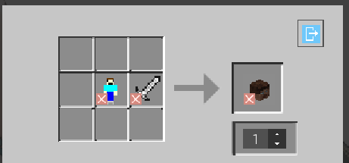

human and sword is head

lol



i added aiden as a item .

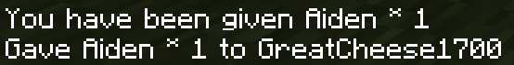



you can eat it and get max hunger filled or you can do 10k damage with it lol



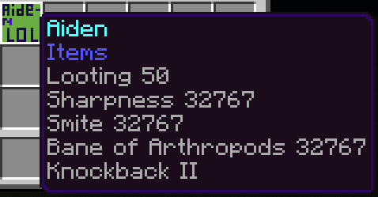

i havae made aiden the item do 26,383 damage

instead of just 9,999

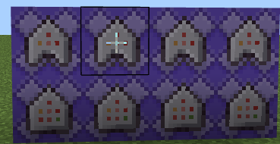

protection



lol

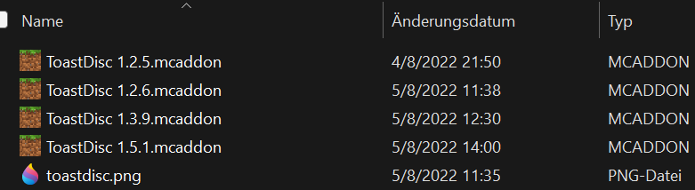

4 version lol

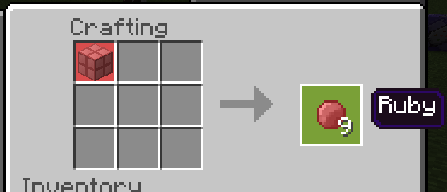

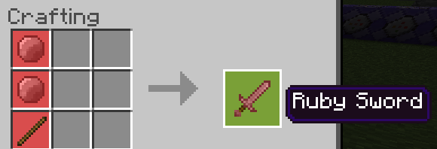

lol forgot ruby block recp

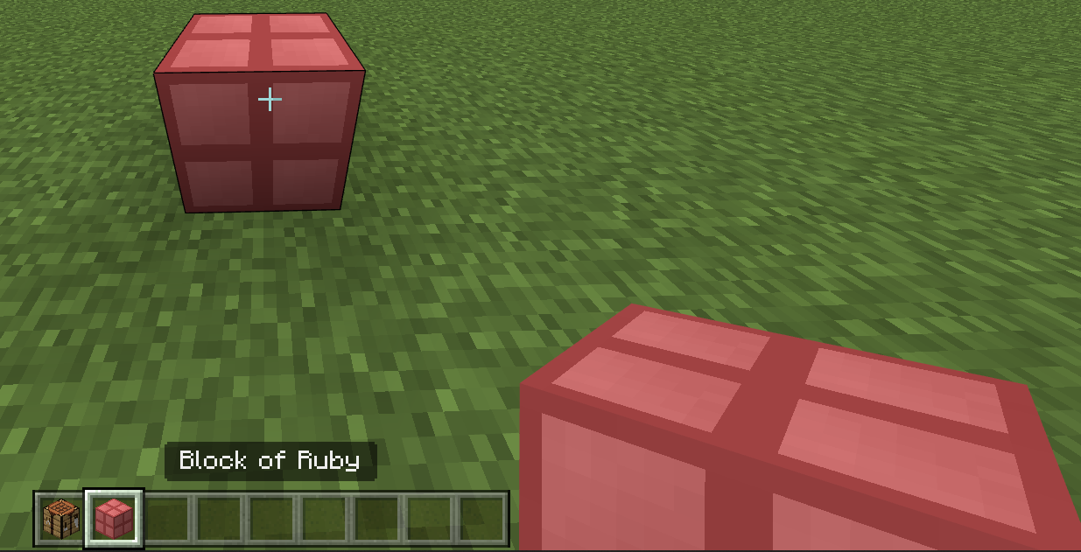

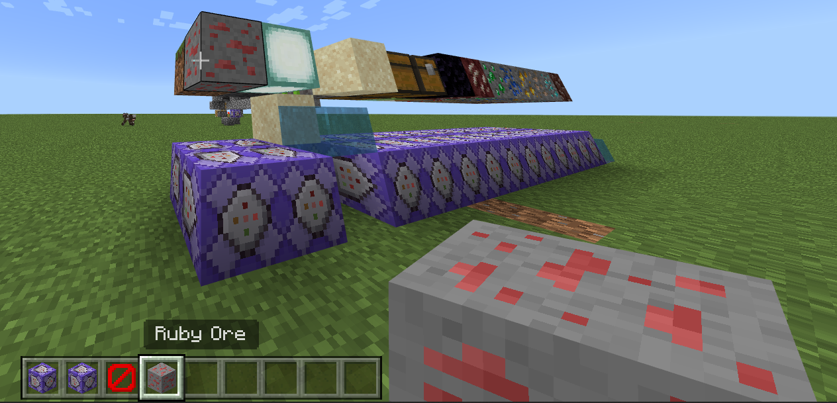

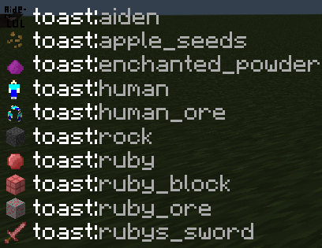

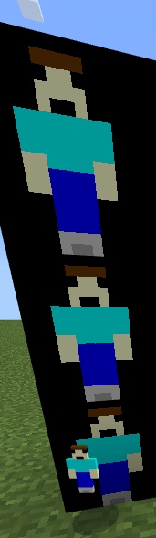

Steve and his block counterpart

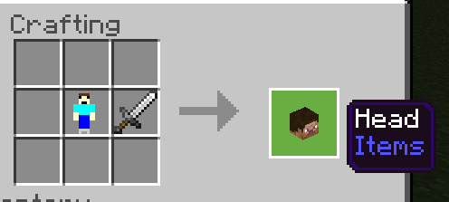



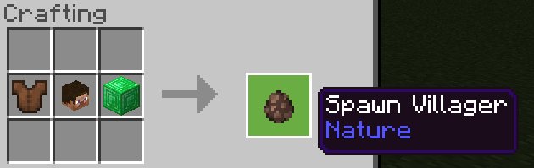

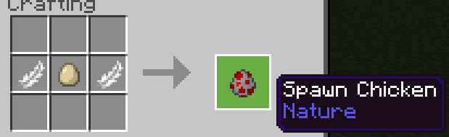

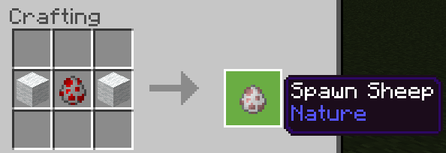

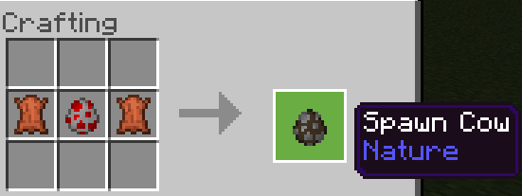

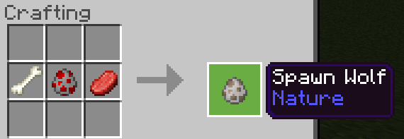

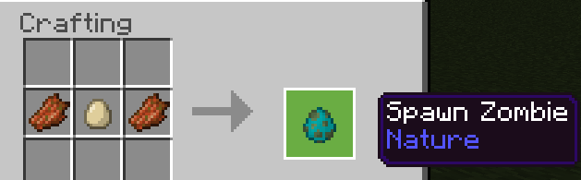

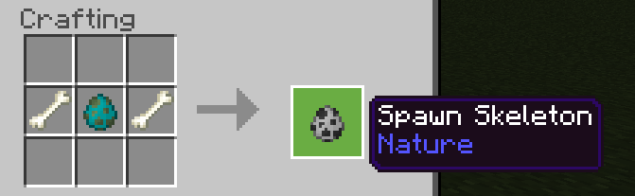

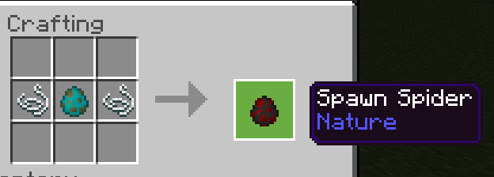

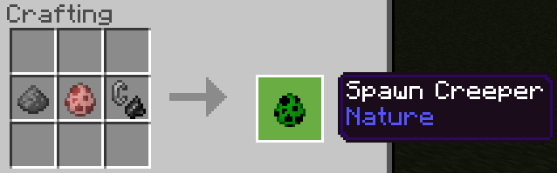

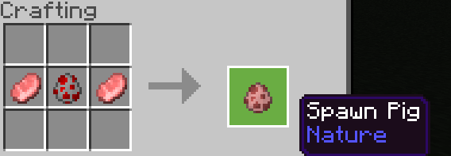

i made a document with all the stuff i added lol [this document]

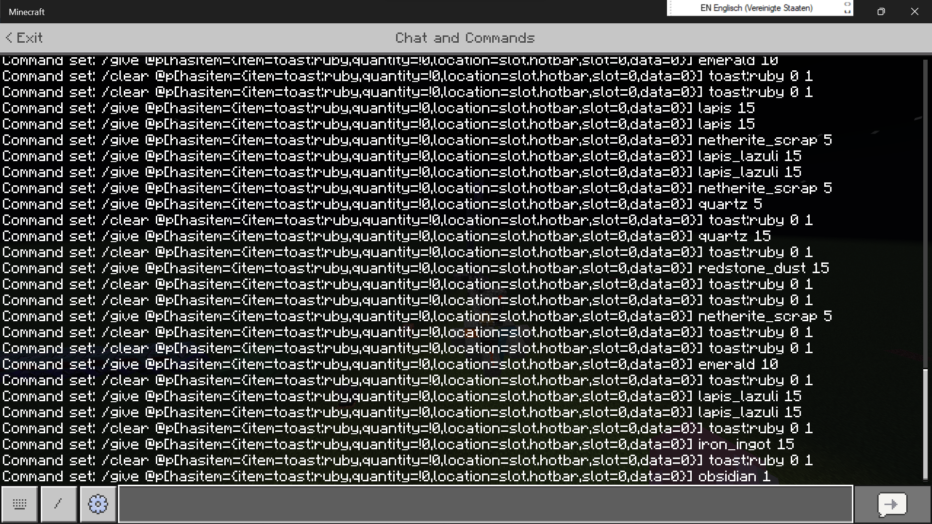

i made shops lol

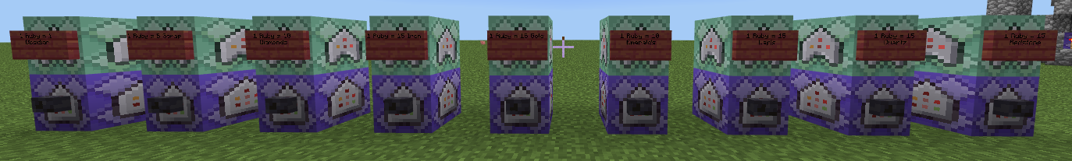

2 Rubys is equal to 1 netherite ingot, a gold, and 1 scrap

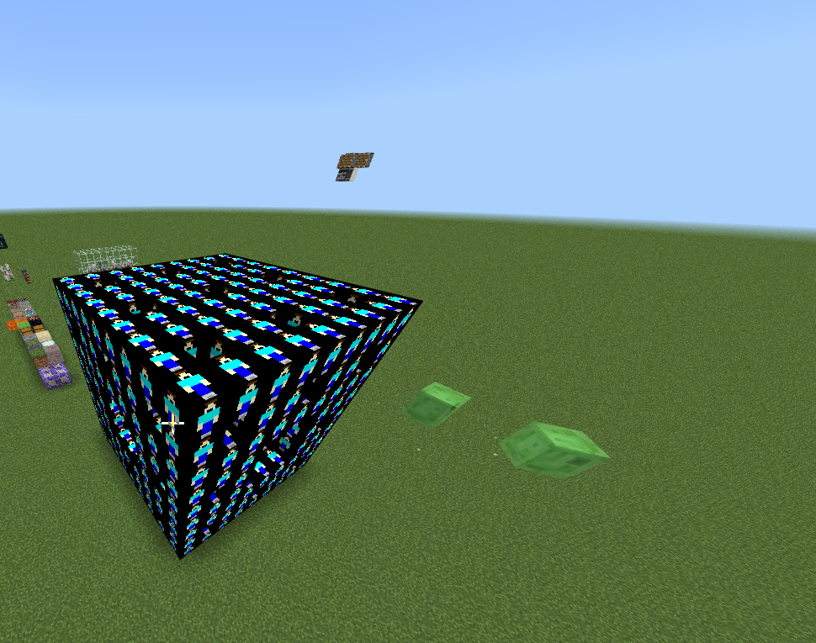

steve fractal

fixed steve fractal

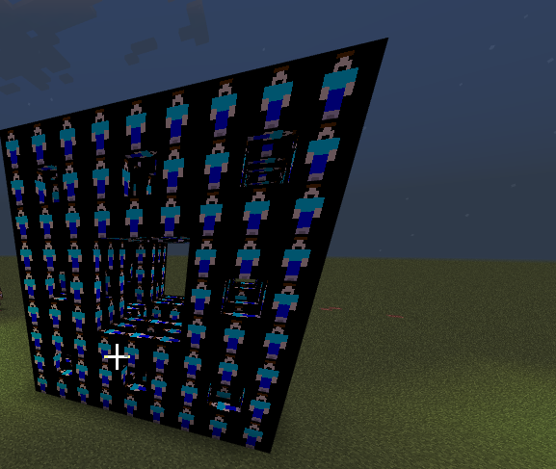

test world 1000

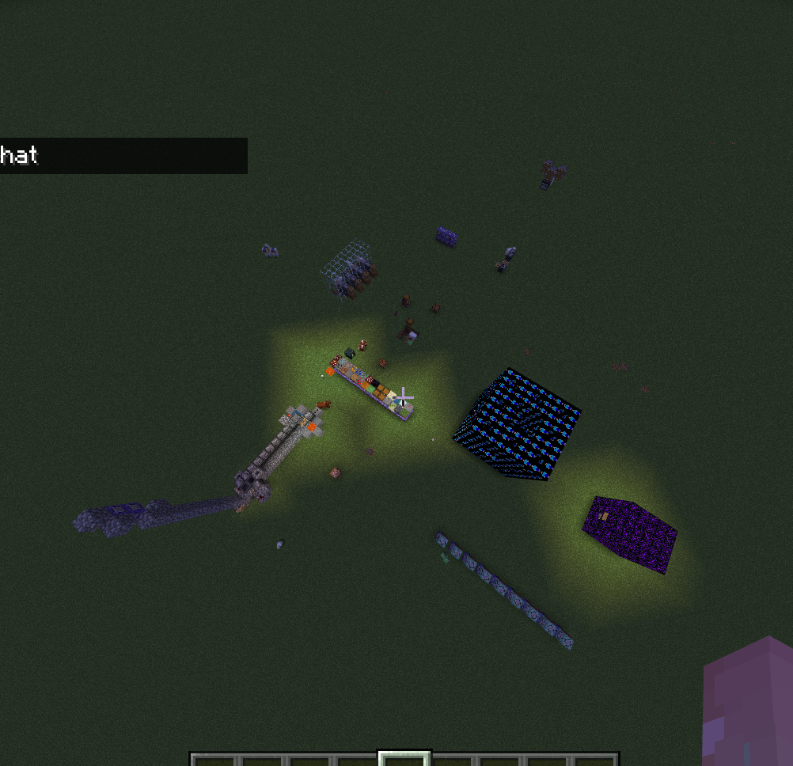

.

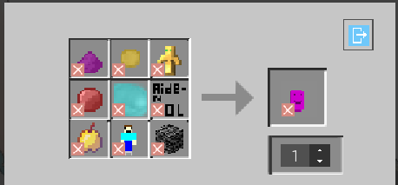

power of aiden recp:

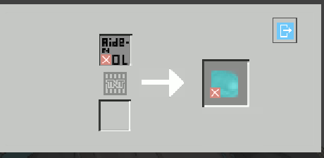

it requires a blast furnace :)

added wax, wax sword and wax block





sword does 4 dmg and can be used 5 times



also the purple thing is beanos

multi dimensional rift recp:

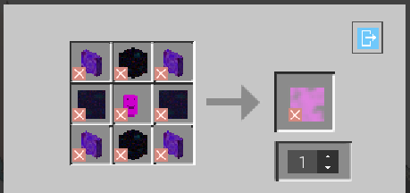

the core recp

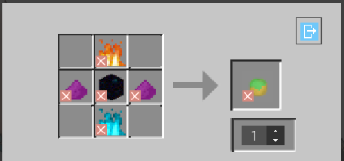

fire recp

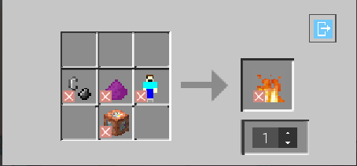

soul fire recp

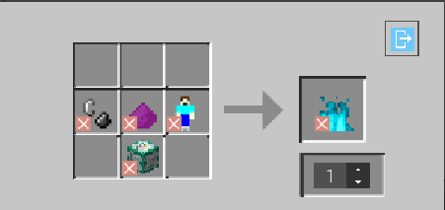

command block recp

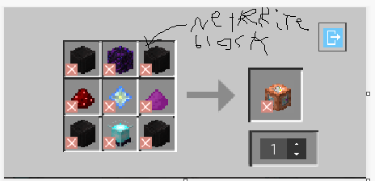

chain command block recp

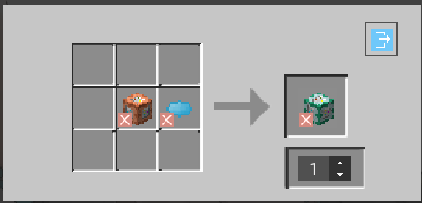

repeating command block recp

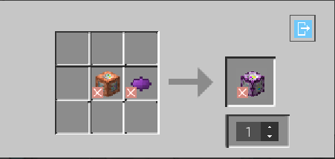

aiden 2 recp

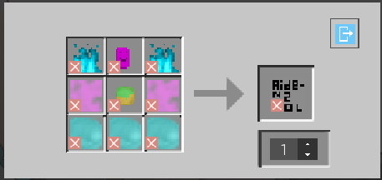

also aiden2 does 120k damage without enchantments

a guide on how to make aiden2

<https://survexe-pc.github.io/jscodingknowledge/How-2-Make-Aiden2.html>

updated enderpearl recp

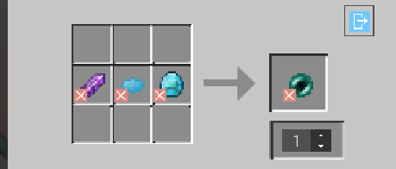

Aiden recp

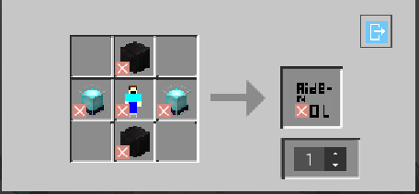

The next day… [6/8/2022]

reeeeeeeeeeeeeeeee

how 2 make aiden 2:

<https://survexe-pc.github.io/jscodingknowledge/How-2-Make-Aiden2.html>

1.7.3 documentation:

<https://survexe-pc.github.io/jscodingknowledge/ToastDisc-1.7.3-log.html>

(1.7.5 documentation is under beta lol)

the documentation for 1.7.5 is 22 pages long

(message to friend if he reads this)

Will u pls play mc with me…

Current damages:

(1.7.5 and below);

Aiden: [Durability:Inf, Atk Dmg: 9,999]

Wax Sword: [Durability: 5, Atk Dmg: 0]

Ruby Sword: [Durability: 1,164, Atk Dmg: 18]

Power of Aiden: [Durability: Inf, Atk Dmg: 50,000]

Aiden2: [Durability: Inf, Atk Dmg: 128,000]

Beanos: [Durability: Inf, Atk Dmg: 100,000]

(1.7.6 below)

(1.7.6 through 1.8.1 is the Combat Nerf Update);

Wax Sword: [Durability: 5, Atk Dmg: 4]

Power of Aiden: [Durability: Inf, Atk Dmg: 0]

Beanos: [Durability: Inf, Atk Dmg: 0]

Aiden: [Durability: 23,423, Atk Dmg: 14] (Stack size nerfed to 1)

Aiden2: [Durability: 24,534, Atk Dmg: 27] (Stack size nerfed to 1)

(1.8.3 Minor Nerf)

Aiden: No longer food

Aiden 2: No longer food

(documentation will now be moved to 1.8.4 log)